**COMPARISON AND IMPLEMENTATION OF MPPT CONTROLLERS**

Project Report

Submitted by

**SAYANTIKA PAUL SUYASH BHATT**

170906082 170906140

Under the guidance of

DR. R. SHIVARUDRASWAMY

Associate Professor

Electrical and Electronics, MIT

MAHE, Manipal

in partial fulfilment of the requirements for the award of the degree of

# **BACHELOR OF TECHNOLOGY**

# **IN**

# **ELECTRICAL AND ELECTRONICS ENGINEERING**

# 

# **DEPARTMENT OF ELECTRICAL AND ELECTRONICS ENGINEERING**

**MANIPAL INSTUTUTE OF TECHNOLOGY**

(A Constituent Unit of Manipal Academy of Higher Education, MANIPAL-576104, KARNATAKA, INDIA

May 2021

**A screenshot of a cell phone

Description generated with very high confidenceDEPARTMENT OF ELECTRICAL AND ELECTRONICS ENGINEERING**

Manipal

20th May, 2021

**CERTIFICATE**

This is to certify that the project titled **COMPARISON AND IMPLEMENTATION OF MPPT CONTROLLERS** is a record of the bonafide work done by **SAYANTIKA PAUL** (*Reg. No. 170906082*) and **SUYASH BHATT** (*Reg. No. 170906140*) submitted in partial fulfilment of the requirements for the award of the Degree of Bachelor of Technology (B.Tech.) in **ELECTRICAL AND ELECTRONICS ENGINEERING** of Manipal Institute of Technology, Manipal, Karnataka, (A Constituent Institute of Manipal Academy of Higher Education), during the academic year 2020-2021.

|  |  |
| --- | --- |
| **Dr. R. Shivarudraswamy**  **Internal Guide**  *Associate Professor*  *Dept of E&E,*  *M.I.T., MANIPAL* | **Prof. Dr. Chandrashekara S Adiga** *HOD, Dept of E&E,*  *M.I.T., MANIPAL* |

**ACKNOWLEDGMENTS**

We would like to thank the Director, Department of Electrical and Electronics Engineering, MIT Manipal and our department HOD for guiding us to successfully undertake this project work. We would also like to take this opportunity to express our deep sense of gratitude to our guide Dr. R. Shivarudraswamy. We are obliged to Sir for providing us his valuable guidance at every stages of the project. Without his suggestions, advice and encouragement we wouldn’t have been able to complete the project. We also owe wholehearted appreciated to Deeskshita ma’am for guiding and assisting us during the project.

**ABSTRACT**

Since the concern for the climate change issue has been at an all-time high lately, there have been much more interest and development in the areas of non-conventional sources of energy. One of which is the harnessing solar energy via Photovoltaic system. However, there are certain challenges when it comes to a conventional photovoltaic cell, one of them being the efficiency. It is estimated that the efficiency of photovoltaic cells can be only up to 15% to 20% only, also the output tends to be irregular as the input of the Photovoltaic module is subjected to change considering the input parameters which are the irradiance and temperature. Hence for a better efficiency in terms of both cost and power, there needs to be a solution.

In the current vs voltage, and power vs voltage graph of the photovoltaic system, there is a point called the maximum power point (MPP), this point has the maximum power output irrespective of the input conditions. There are many algorithms which are implemented to achieve this point and hence we get a better efficiency in terms of both cost and power. For getting this we will be implementing and analysing two different algorithms which are the Perturb and Observe algorithm and Incremental Conductance algorithm.

Upon comparison of the two algorithms and analysis it was found that the Incremental Conductance gave better results in terms of efficiency. Perturb and Observe also gave significant improved efficiency values, however between the two Incremental Conductance gave better values and this was as we had expected.

The project is focused on the study of performance of both Perturb and Observe and Incremental Conductance algorithms using a boost converter which is used to generate the duty cycle. We can see that the model proposed by us is has more advantage in terms of speed, simplicity and convergence on the characteristics of PV model. Since it is a purely simulation based project, the entire simulation study of the PV system has been done via MATLAB/Simulink.

|  |  |  |  |  |  |  |  |
| --- | --- | --- | --- | --- | --- | --- | --- |
| **TABLE OF CONTENTS** | | | | | | | |
|  | | | | | | | Page No |
| Acknowledgement | | | | | |  | i |
| Abstract | | | | | |  | ii |
| List Of Tables | | | | | |  | v |
| List Of Figures | | | | | |  | vi |
|  | | | | | | | |
| **Chapter 1** | | | | | **INTRODUCTION** | |  |
|  | | **1.1** | | Introduction | | | 1 |
|  | | **1.2** | | Motivation | | | 1 |
|  | | **1.3** | | Relevance of the work | | | 2 |
|  | | **1.4** | | Impact of the work on the environment and other factors | | | 2 |
|  | | | | | | | |
| **Chapter 2** | | | | | LITERATURE REVIEW AND OBJECTIVES | |  |
|  | | **2.1** | | Literature Review | | | 3 |
|  | | **2.2** | | Background Theory | | | 3 |
|  | | **2.3** | | Objectives | | | 4 |
|  | | | | | | | |
| **Chapter 3** | | | | | METHODOLOGY | |  |
|  | 3.1 | | Simulation Medium | | | | **5** |
|  | 3.2 | | Design of the Model | | | | **5** |
|  | 3.3 | | Perturb and Observe Algorithm | | | | **7** |
|  | 3.4 | | Incremental Conductance Algorithm | | | | **9** |
|  | | | | | | |  |
| **Chapter 4** | | | | | **CONTRIBUTION OF EACH STUDENT** | |  |
|  | | **4.1** | | Contribution of student 1 (Sayantika Paul) | | | 11 |
|  | | **4.2** | | Contribution of student 2 (Suyash Bhatt) | | | 13 |
|  | | | | | | | |
| **Chapter 5** | | | | | **RESULT ANALYSIS** | |  |
|  | | **5.1** | | Case wise graphical analysis of both the algorithms | | | 14 |
|  | | **5.2** | | Numeric Value analysis | | | 18 |
|  | | **5.3** | | Comparison Between the two algorithms | | | 20 |
|  | | | | | | | |
| **Chapter 6** | | | | | **CONCLUSION AND FUTURE SCOPE** | |  |
|  | | **6.1** | | Conclusion | | | 22 |
|  | | **6.2** | | Future Scope | | | 22 |
| **REFERENCES** | | | | | | | 23 |
| **ANNEXURES (OPTIONAL)** | | | | | | | 24 |
| **PROJECT DETAILS** | | | | | | | 25 |

**LIST OF TABLES**

|  |  |  |
| --- | --- | --- |
| **Table No** | **Table Title** | **Page No** |
| 1 | Case 1 Graphs | 14 |
| 2 | Case 2 Graphs | 15 |
| 3 | Case 3 Graphs | 16 |
| 4 | Case 4 Graphs | 17 |
| 5 | Numeric Values of Perturb and Observe algorithm | 18 |
| 6 | Efficiency and error w.r.t. expected value for Perturb and Observe algorithm | 18 |
| 7 | Numeric Values of Incremental Conductance algorithm | 19 |
| 8 | Efficiency and error w.r.t. expected value for Incremental Conductance algorithm | 19 |
| 9 | Efficiency comparison of both the algorithms | 20 |
| 10 | % error w.r.t the expected value for both the algorithms | 21 |

**LIST OF FIGURES**

|  |  |  |
| --- | --- | --- |
| **Figure No** | **Figure Title** | **Page No** |
| 1 | Design of the model | 5 |
| 2 | Solar Panel with output terminals | 6 |
| 3 | Boost converter | 6 |
| 4 | Load along with the output terminals | 7 |
| 5 | Perturb and Observe code | 7 |
| 6 | Perturb and Observe flow chart | 8 |
| 7 | Incremental Conducatnce code | 9 |
| 8 | Incremental Conductance flowchart | 10 |
| 9 | Case 3 Irradiance input | 16 |
| 10 | Case 3 Temperature input | 16 |
| 11 | Detailed model diagram | 24 |

**CHAPTER 1**

**INTRODUCTION**

* 1. *Introduction*

Energy is necessary for working of anything and everything in today’s world. However, in today’s world majority of the population is strictly relying on fossil fuels as the source of energy. We have been using these sources of energy for less than the past 200 years, however with the rate at which it is being consumed globally it is estimated that the fossils fuels will only last for the less than 50 years. These fuels take millions of years to be formed and with the escalating consumption rate it can be positively said that eventually there won’t be any availability of fossil fuel for the foreseeable future. Both extraction and consumption of fossil fuels comes with a lot of shortcomings. Looking at the demands and the speed at which the consumption is taking place we can easily say that the industry is currently only adaptable to this type of energy source and has to be prepared for the inevitable future. To face what the future withholds, we need to look for alternative sources of energy and adapt our industry according to it. Alternative sources of energy that we need to bring into the picture should not only be clean and green but also be easily available and not perishable. Currently some industries and domestic outlets are relying on such sources, although the numbers are quite low. These sources can include wind, water, solar, geothermal and biomass. Harnessing solar energy is one of the alternatives which has been widely implemented since the source of solar energy is highly ubiquitous.

* 1. *Motivation*

Climate change had been a concern of everyone around us lately. It is known that fossil fuels are perishable and won’t last forever, and the added concerns of the environment hazards which come with the utilization of these have led people to look for alternatives. As mentioned earlier, in PV modules, the power output depends on the input conditions which are solar irradiance and environmental temperature. If the input of a system is inconsistent, naturally the output is inconsistent. But for the sake of better efficiency in terms of power and cost of the PV model system we need to find a solution. Which is the maximum power point. When it comes to PV modules there is a point on the characteristic curve of current vs voltage and power vs voltage where this point is available. It was in the 1980s when maximum power point tracking system first came into existence in terms of finding solutions towards higher power efficiency of PV module.

For the finding the maximum power point tracking, a maximum power point tracking controllers is required to be placed between the photovoltaic module and the load. There are various algorithms present out there which are implemented to find the maximum power point. Some of the algorithms which are used are Perturb and Observe algorithm, Incremental Conductance algorithm, constant voltage algorithm, open voltage algorithm etc. For the purpose of observation and analysis we will be implementing Perturb and Observe algorithm and Incremental Conductance algorithm. According to certain studies it is said that the output power of PV modules can be increased by 20 to 30 percent by utilizing this. We also use boost converter in this case.

* 1. *Relevance of the work*

Currently India ranks third in harnessing solar energy and it is estimated that by the year 2022 India will be harnessing 100 Giga Watt of solar power with an estimated budget of US$ 100 billion. In India solar energy is harnessed in three ways, which are; roof top based which can be used for industrial, commercial and domestic purposes; large scale or ground based grid connected, which can be seen in large areas such as solar parks and finally off grid power which can be seen locally in street lamps, solar cookers etc. Currently around the world 629 Giga Watts of power is installed.

* 1. *Impact of the work on the environment and other factors*

Demand for power is increasing at an exponential rate in the past few years, as a result it has been affecting the environment. Moving towards sustainability is the ideal option that we can see right now. Harnessing solar power is the ideal solution that we can see right now. A rise in demand in electrical vehicles can be seen right now as a result, to meet the power demands we can rely on solar energy this will lead to the growth of the industry and also boost the economic growth. For operation purposes it doesn’t require any cost heavy external factor and hence production cost is almost nil.

Post installation of the solar power plants there is no emission of greenhouse gases. Unlike the conventional sources of energy where we can see that it causes significant amount of water pollution and oil pollution, in the case of solar power plant they do not require water for cooling and hence do not cause water pollution.

This method also promises long term durability and prevents us from relying on conventional sources of energy eventually.

**CHAPTER 2**

**LITERATURE REVIEW/ BACKGROUND THEORY/AND OBJECTIVES**

* 1. *Literature Review*

**N.Pandiarajan and Ranganathan Muth**, this paper gave us insight as to how the implementation and simulation of the PV modules take place briefly in a step by step approach in MATLAB/Simulink.

**Alpesh P.Parekh, Chirag T .Patel and Bhavarty N. Vaidya** through this paper we could understand the detailed circuit designing part of the photovoltaic model, and gave us easy understanding on how to design our own model.

**Pandiarajan N, Ramapraphu R, and Ranganath Muthu**, this paper gave us another perspective to the design of the PV model, which helped in better development of our model design. We gathered insights from the MATLAB/Simulink model and designed our own model.

**A. Dolara, R. Franda, S. Leva**, this paper has given insights to different algorithms that can be implemented. It gave us a better understanding of the algorithms that can be implemented.

**Anuradha, S. Kumar**, Incremental Conductance algorithm has been explained here briefly, this has helped us to get in-depth understanding of the concept.

* 1. *Background Theory*

Maximum Power Point Tracking Controllers are used to improve efficiency of photovoltaic modules. These are connected in between the PV module and the load. Maximum Power Point Tracking Algorithms are used to find the MPP and hence improve efficiency.

In terms of recent developments, currently market value of these controllers are at $312.1 million (USD) and can go up to $395.4 million (USD)in 5 years. Highest demand can be seen in the norther American region with about 20% of the total. Of the two types of charge controllers which are PWM and MPPT, MPPT contributes to 40% of the total sales.

Coming to the algorithms, in Perturb and Observe method we will be basically incrementing or decrementing depending on what position of the graph we are at. (Here the graph is between power and voltage). If the point is at where the power is increasing then according to this algorithm, power is increased until maximum power is reached, and if the slope is going down and the point is beyond the maximum power point then effort is made to reduce the voltage so that the maximum power point is reached. Next coming to incremental conductance the incremental changes in the controller is taken into the picture.

According to the Power vs voltage graph the MPP point lies where the slope is zero.

Hence,

dP/dV = d(VI)/dV

I + V(dI/dV) = 0

This ultimately gives, dI/dV = -I/V

And this condition needs to be satisfied in this algorithm to achieve MPP.

* 1. *Objectives*
     1. *Main Objective*

The objective of this project is implement and compare two algorithms to get maximum power output with the help of MPPT controller and to find the best amidst the two.

* + 1. *Individual Objective*

Objective of Student 1

Our objective of this project is to implement the algorithms to establish the maximum power output of PV module using MPPT controllers

Objective of Student 2

Our objective of this project is to run simulation using MATLAB and to improve the efficiency of the PV system.

**CHAPTER 3**

**METHODOLOGY**

* 1. *Simulation Medium*

This Project is entirely based on simulation of the PV module. To ideally observe and analyse the working and the output of the module virtually the simulation is required to be done on Simulink as it has all the necessary components which can be simulated as per the requirement of the experiment. Hence we will be using MATLAB/Simulink for this particular project.

* 1. *Design of the Model*

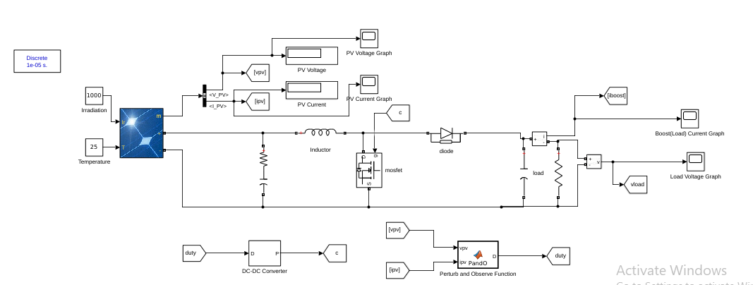

Fig. 1 : Design of the model

Ultimately we need to integrate the MPPT controller to the PV module, for this we will separate the entire design into three parts for the sake of explanation.

The basic structure design that we can see in Fig. 1 is such that we have the solar panel (Photo Voltaic Panel or PV Panel) first, input for which are the solar irradiance and the temperature of the surrounding environment. The PV panel is further connected to the load which is this case is a resistance, via the boost converter. The boost converter gets pulse from the dc to dc converter which receives input from the MPPT controller which has the required MPPT function, in this case the Perturb and Observe Algorithm function.

.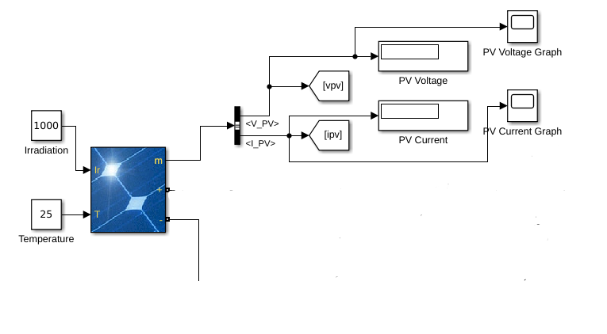

Fig. 2: Solar Panel with output terminals

Fig. 2 represents the Solar Panel on which we will conducting the experiment. The solar panel had two inputs which are irradiance and temperature, we will be doing analysis over a variety of ranges and combinations of the two inputs for the experimentation purpose. Scopes have been added to view the PV voltage and PV current which is ultimately fed into the next part of the entire module. We are considering 5 parallel strings, 1 series connected module string and 36 cells per module. It is important to note, here vpv and ipv are the PV voltage and PV current respectively.

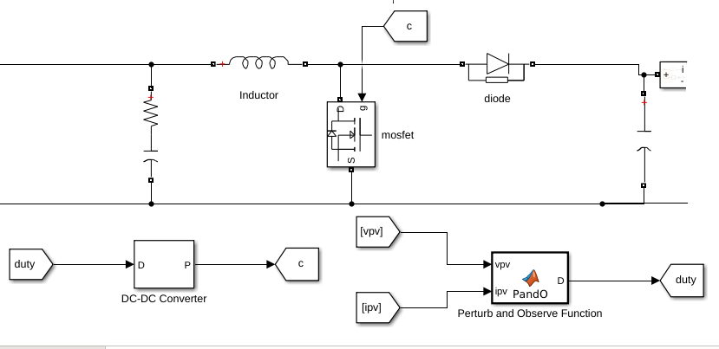

Fig. 3: Boost converter

In the Fig3. we can see that initially we have connected resistance and capacitance in series which is connected to the PV module on one side and to the boost converter on the other side. The reason behind connecting resistance and capacitance in series is for making sure there is less variation of the voltage from the solar panel. For designing purpose, we have taken the values to be 0.1 ohms and 5 mF.

For the boost converter we require a Mosfet, which needs to be fed pulse, this pulse is received via a dc to dc converter which is used to step up the voltage, the input of the dc to dc converter is the output of the Perturb and Observe Algorithm function which is implemented on the vpv and ipv (as noted above, it is the PV voltage and the PV current.)

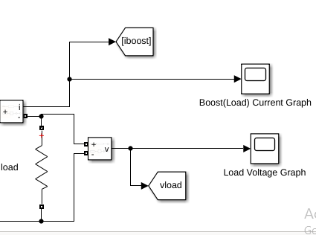

Fig. 4: Load along with the output terminals

Finally, for the sake of simplicity we have taken a resistance as the load, which is finally connected to scope for the output, this can be seen in Fig. 4

* 1. *Perturb and Observe Algorithm*

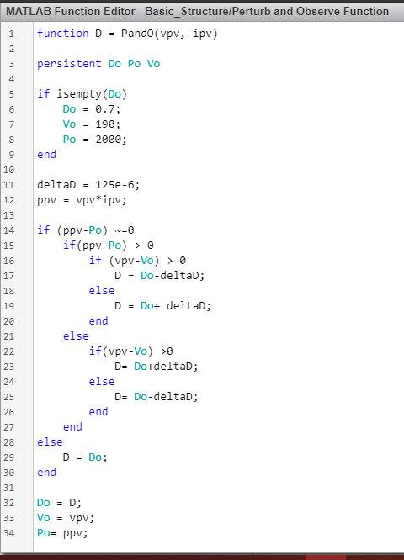

Fig. 5: Perturb and Observe code

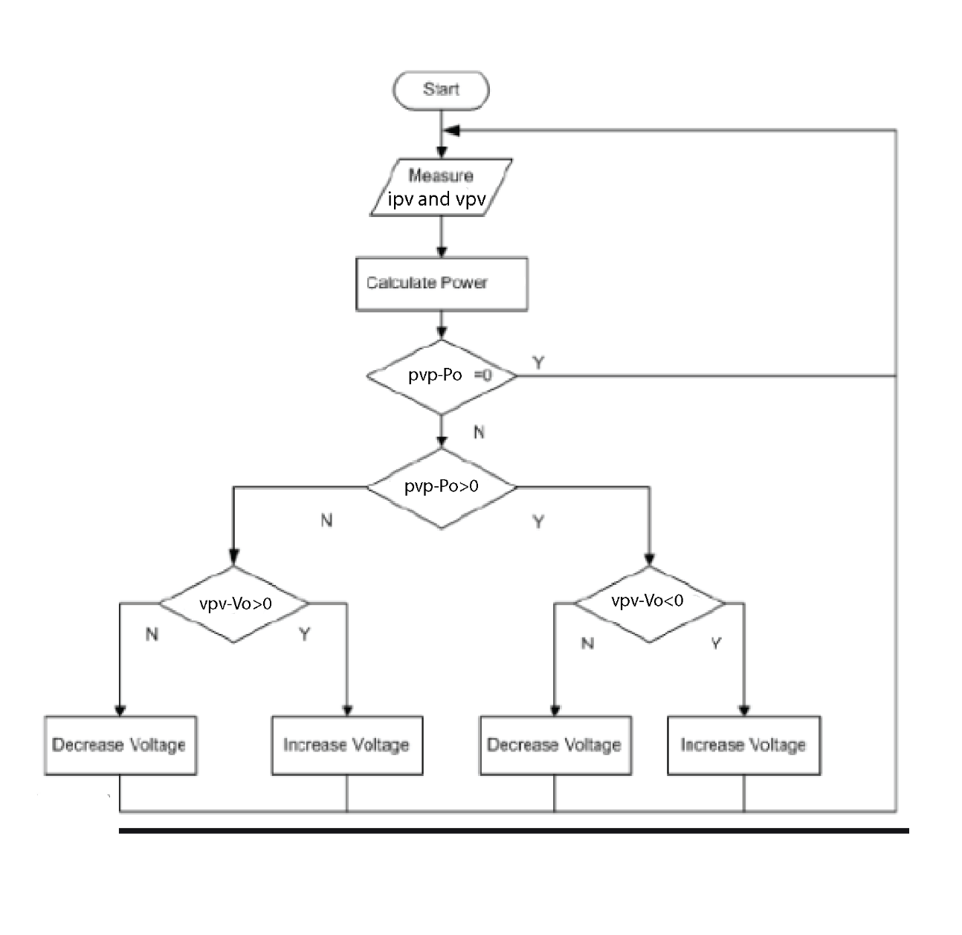

Fig. 6: Perturb and Observe flow chart

According to this algorithm initially the values of current and voltage at the output of the PV module are measured, which are basically ipv and vpv. Then the power across the modul is measured which is the product of both the values. Following which the intial values of duty cycle, power and voltage are set. We make sure that incrermental increase of the value of the duty cycle or the value of delta is also set. And according to the conditions we will increase or decrease the duty cycle to ultimately achieve the maximum power point. The code used can be observed in the Fig. 5 and the flowchart is in the Fig. 6

* 1. *Incremental Conductance Algorithm*

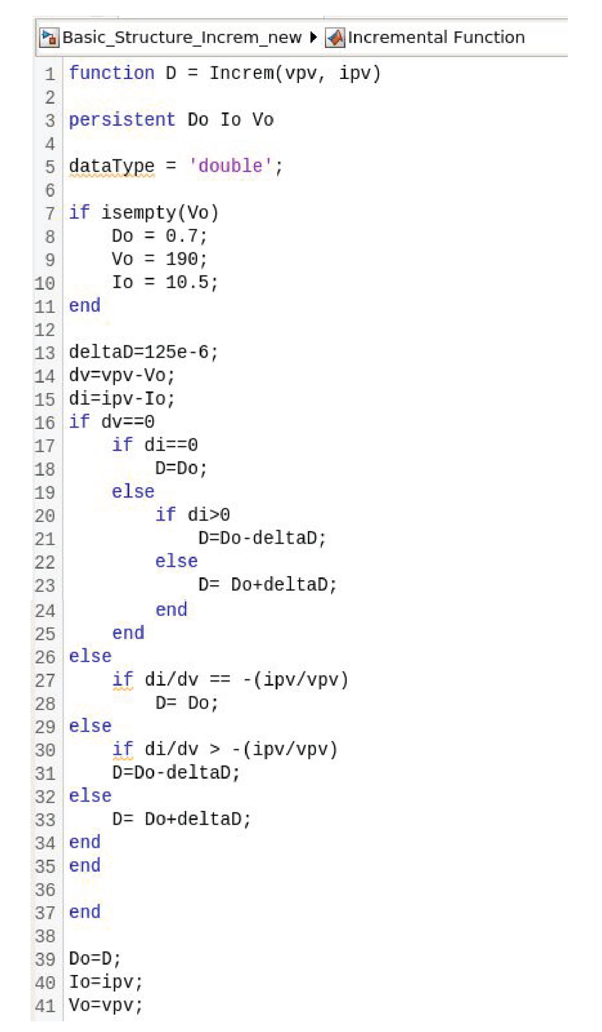

Fig. 7: Incremental Conducatnce code

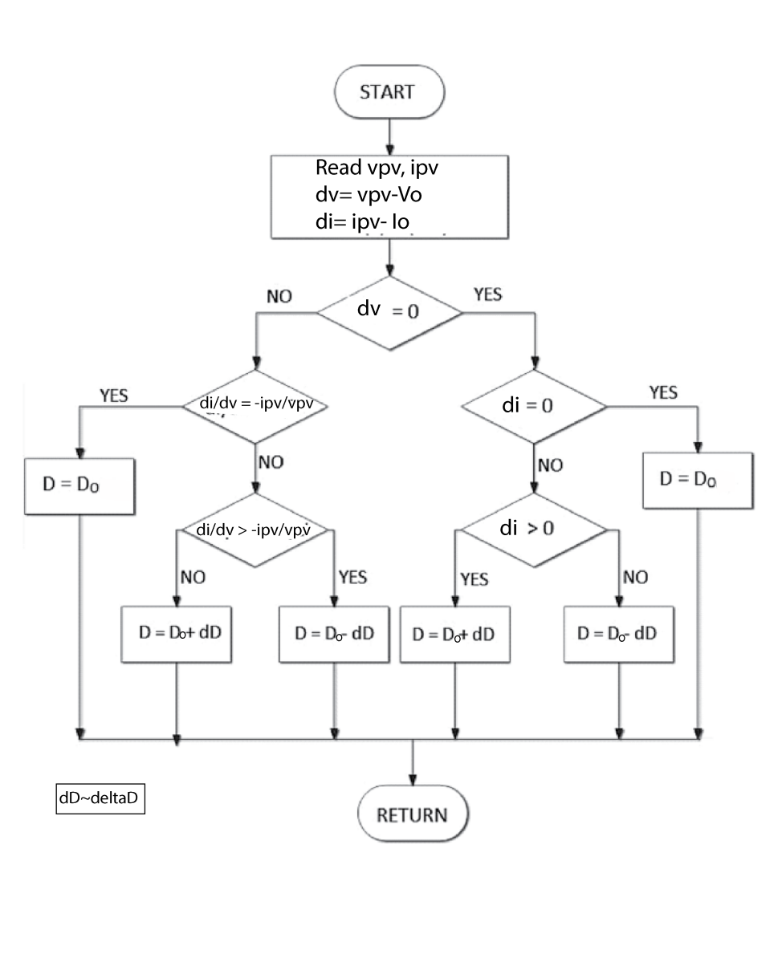

Fig 8: Incremental Conductance flowchart

According to this algorithm initially the values of current and voltage at the output of the PV module are measured, which are basically ipv and vpv. The intial values of duty cycle, current and voltage are set. We make sure that incrermental increase of the value of the duty cycle or the value of delta is also set. These are then subtracted with each other, current with current and voltage with voltage to be obtain dv and di. And according to the conditions in this case they intially start with checking if dv is null, following this condition we check di/dv condition in terms of ipv and vpv and we also check di condition. Finally, we will increase or decrease the duty cycle to ultimately achieve the maximum power point. The code used can be observed in the Fig. 7 and the flowchart is in the Fig. 8

**CHAPTER 4**

**CONTRIBUTION OF EACH STUDENT**

* 1. *Contribution of Student 1: (Sayantika Paul)*

This project has been carried out in various stages. First one being the research stage. Here I read a few research papers based on MPPT controllers, to understand the concept behind it. This gave me in depth knowledge in the concept behind the project and allowed me to figure out how the project would further proceed. Following reading about the theory and concept behind the project, next goal was to choose the algorithms that would be used in the project. I had to choose the two different algorithms that would be implemented and analysed in the project. Upon a meticulous discussion with Sir, we came to a conclusion that we would be working on Perturb and Observe Algorithm first, following which we would be working on Incremental Conductance algorithm. The goal here was to first design the model on which the implementation would take place and use the same model for the implementation of both the algorithms. Upon confirming the algorithms on which the project would be primarily I proceeded to the next stage.

In the second stage, I designed a PV module without an MPPT controller to just analyse the working of the model. The design of the model was made using the tools provided on Simulink. This design was just the beginning stage of the final model, and the goal here was to understand and see how the model comes together and work. This was to understand the connections and the configurations of the system.

Next came the third stage, here I had to design the boost converter which is an integral part of the final the final model design. Considering the formulae, the input values and the requirement of the system, the specifications of all the components of the boost converter were calculated and designed. I designed this entire converter on the simulation software Simulink (MATLAB) (to use it further in the project)

Finally, the boost converter had to be integrated with the photovoltaic module to finally make the model. This again was designed on Simulink(MATLAB), using the various tools available on it. The project required various output to be taken out from different nodes. Along with the output display, I also added graph display to study the wave forms of various output. Here during the designing, I had to integrate the function for implementing the algorithm, where later the code was added which is indirectly connected to the boost converter. Now, because I wanted the power to be displayed along with the output values of the current and voltage of the output side and the photovoltaic module side I added multiplication function as well for the calculation of the power.

After I was satisfied with the model design which included the integration of boost converter and the other parts, came the next stage where I wrote the code for implementation of the first algorithm that is the Perturb and Observe algorithm. But for writing the code I had to understand the concept behind Perturb and Observe algorithm. I studied the algorithm, understood the various parameters and finally, created the flow chart to refer while writing the code. Initially the code came out to be fine, except for a few syntax errors which I eventually rectified upon analysing. Upon rectifying the code ran smoothly without any errors and then I proceeded further.

Next I ran the code, which simulated the entire system. To analyse the system, I was advised to take in various iterations of input parameters and observe the output values. I simulated under different conditions and tabulated the output values of all the conditions. Since I had also added display to view graphs for all the possible cases I even viewed and observed the graphs to see the irregularities and transience. Further I snipped all the different wave outputs for all the different conditions as well. This marked the end implementation of one of the algorithms of the total two algorithms.

In the next stage, I had to study the Incremental Conductance algorithm. I went through various articles to understand this algorithm in depth. Upon understanding the algorithm, I made the flowchart to refer while writing the code. Following which I wrote the code for this algorithm. For the Incremental Conductance algorithm, I used the same model which I used for Perturb and Observe algorithm as I would compare the output on the basis of the algorithms not on the basis of the specifications of the components used. Hence for the MPPT function I included the code for Incremental Conductance (by just substituting the Perturb and Observe code with the Incremental algorithm code). But the process in this case wasn’t as smooth as expected. There was syntax error in the code as I could see. I ran the code, but the output values deviated vastly from the expected values. Further to rectify the error in the output I made changes in the design of the model. After this I ran the code, but their output was still not according to the expected output. The values were quite abrupt, because it was expected to give better results. Upon analysis I realised there was semantic error in the code. After finding the error I rectified it and ran the code again, this time the code ran flawlessly and the outputs were as expected. I tabulated the numeric outputs and snipped the graphs for reference and comparison with respect to the previous algorithm.

Finally, as the implementation of both the algorithms was complete, it was time to compare and analyse. I had made the tabulation columns already (with the numeric values of all the outputs; both along the PV side and the load side), so it was time for finding the errors in the output power with respect to the input power and calculating the efficiency of the power values in both the cases. I made the required calculations and tabulated it. Since I had also snipped the required graphs for all the cases I could also compare the graphs for different cases for analysis purpose. This gave me insight to what my objective of the project was and helped me find the better amidst the two algorithm.

Apart from the research, conduction and implementation of the project another added task here was the documentation part of it. I significantly contributed to the documentation of the synopsis, the midterm report, and regularly made the monthly and weekly reports required for the project. I maintained an observation notebook to note down necessary points, formulae and flow chart.

* 1. *Contribution of Student 2: (Suyash Bhatt)*

First and foremost, when we decided the topic of MPPT controllers the discussion had to be regarding the approach and methodology to carry out the project .After discussing and going through research paper and some books related to methods such as Open Circuit Voltage,Short Circuit Current ,Artificial Neural Network etc. The Algorithm chosen was Perturb and Observe and Incremental Conductance based on discussions around complexity,cost to install,speed of convergence,sensors required ,hardware implementation and effectiveness.Since a PV system is expensive to build,it is important to harness all of the available power output.So,the next goal was to design a system using above algorithms which gave us the best chance to get as close to the overall highest efficiency as possible.Types of solar panels (mono-crystalline, poly-crystalline ,thin film etc ) had to be discussed which ultimately resulted in a trade off between cost and efficiency.Next part of the assignment was to discuss cuk ,boost and buck-boost converters.Boost converter was chosen because of its easy implementation and working.The project was divided in two parts one for each algorithm.

Finally simulation had to be done on MATLAB and for that SIMSCAPE ELECTRICAL package was installed in SIMULINK which provides libraries for simulating and modelling of electronics ,mechatronics and electrical power systems.It allows us to develop control systems and test system performance.Then results from both algorithms needed to observed with varying irradiance and temperature.One student took up constant temperature while changing the irradiance and the other student varied the temperature keeping the irradiance constant.Above results were stored in a form of table and that will form the basis of comparison of both algorithms.Second algorithm was a trickier one and few changes to simulink diagram as well as code needed to change .We wrote the code which initially wasn’t working but with the help of our teacher it showed better results eventually .Next part of the problem was observing both algorithms and comparing efficiency and errors of both .Lastly conclusion and drawbacks related to both when applied in a practical scenario were considered.

**CHAPTER 5**

**RESULT ANALYSIS**

* 1. *Case wise graphical analysis for both the algorithms*
     1. *Case 1: Constant temperature (25 degrees Celsius) and Variable Irradiance. (Load=10ohms)*

|  |  |  |
| --- | --- | --- |
| Irr | Perturb and Observe algorithm | Incremental algorithm |
| 200 | C:\Users\MAHE\AppData\Local\Microsoft\Windows\INetCache\Content.Word\po1.1.jpg | C:\Users\MAHE\AppData\Local\Microsoft\Windows\INetCache\Content.Word\ic1,1.jpg |
| 500 | C:\Users\MAHE\AppData\Local\Microsoft\Windows\INetCache\Content.Word\po 1.2.jpg | C:\Users\MAHE\AppData\Local\Microsoft\Windows\INetCache\Content.Word\ic1.2.jpg |
| 1000 | C:\Users\MAHE\AppData\Local\Microsoft\Windows\INetCache\Content.Word\po 1.3.jpg | C:\Users\MAHE\AppData\Local\Microsoft\Windows\INetCache\Content.Word\ic 1.3.jpg |

Table 1: Case 1 graphs

In this case by graphical observation we can see that values with 200 Irradiance show the lowest numeric deviation and values with 500 Irradiance show the maximum. More or less the numeric values are near the expected values (which are 200 Watt, 500 Watt, 1000 Watt respectively)

* + 1. *Case 2: Constant irradiance (1000 Watt/m^2) and Variable Temperature. (Load=10ohms)*

|  |  |  |
| --- | --- | --- |
| Temp | Perturb and Observe algorithm | Incremental algorithm |
| 15 |  |  |
| 25 | C:\Users\MAHE\AppData\Local\Microsoft\Windows\INetCache\Content.Word\po 1.3.jpg | C:\Users\MAHE\AppData\Local\Microsoft\Windows\INetCache\Content.Word\ic 1.3.jpg |
| 35 |  |  |

Table 2: Case 2 graphs

We can observe that as the temperature increases, the deviation in terms of numeric value decreases. Otherwise even in this case the values are more or less near the expected values which is 1000 Watts in this case.

* + 1. *Case 3: variable Temperature and Variable Irradiance*

For this case we have used step responses for both temperature and irradiance and kept the load at 10Ω.

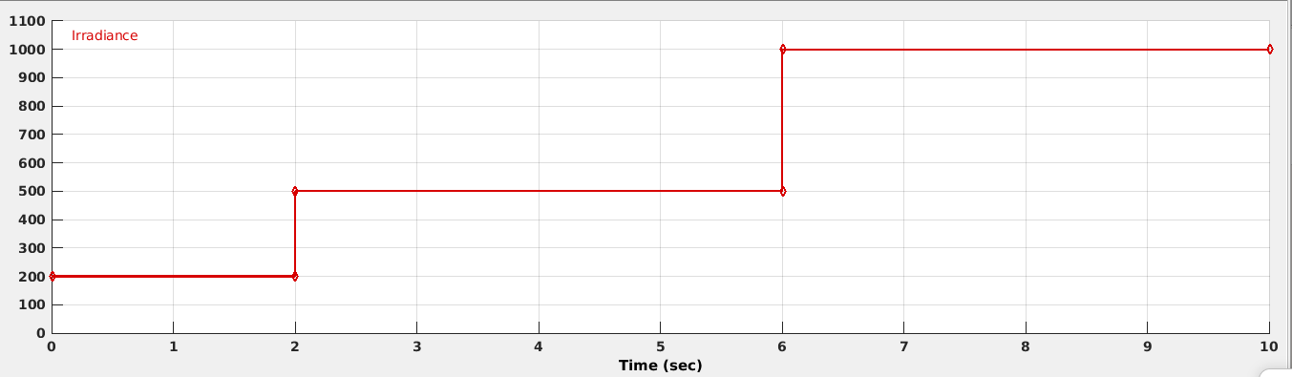

Fig. 9: Case 3 Irradiance input

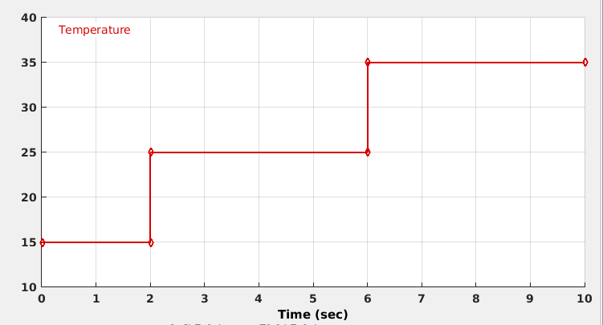

Fig. 10: Case 3 Temperature input

Fig.9 and Fig.10 are the variable input parameters (i.e. the irradiance and temperature)

|  |  |
| --- | --- |
| Perturb and Observe algorithm | Incremental Conductance algorithm |
| C:\Users\MAHE\AppData\Local\Microsoft\Windows\INetCache\Content.Word\po 3.jpg | C:\Users\MAHE\AppData\Local\Microsoft\Windows\INetCache\Content.Word\ic 3.jpg |

Table 3: Case 3 graphs

In this case via the graphical observation there seems to be minimum deviation and the output values are also pretty much near to the expected values which are 200 Watt up to 2 secs, 500 Watts up to 6 secs and 1000 Watts up to 10 secs.

* + 1. *Case 4: Constant temperature (25 degrees Celsius) and Variable Irradiance. (Load=500 ohms)*

|  |  |  |
| --- | --- | --- |
| Irr | Perturb and Observe algorithm | Incremental algorithm |
| 200 | C:\Users\MAHE\AppData\Local\Microsoft\Windows\INetCache\Content.Word\po4.1.jpg | C:\Users\MAHE\Desktop\ic 4.1.JPG |
| 500 | C:\Users\MAHE\AppData\Local\Microsoft\Windows\INetCache\Content.Word\po 4.2.jpg | C:\Users\MAHE\Desktop\ic 4.2.JPG |
| 1000 | C:\Users\MAHE\Desktop\po 4.3.JPG | C:\Users\MAHE\Desktop\ic 4.3.JPG |

Table 4: Case 4 graphs

The maximum deviation can be seen in this case. It is expected that the output power should be 200 Watts, 500 Watts and 1000 Watts like Case 1. However, the deviation persists because of the load condition here.

* 1. *Numeric Value Analysis*

It is important to note that in the following tables different colours, represent different cases:

Case 1

Case 2

Case 3

Case 4

* + 1. *Numeric Values for Perturb and Observe algorithm*

|  |  |  |  |  |  |  |  |
| --- | --- | --- | --- | --- | --- | --- | --- |
| Temperature (in Celsius) | Irradiance  (in Watt/m^2) | Vpv (PV Volatge (in Volts) | Ipv (PV Current (in Amps) | Ppv (PV Power in Watts) | Load current (in Amps) | Load voltage (in Volts) | Load power (in Watts) |
| 25 | 200 | 30.21 | 6.822 | 206.1 | 4.513 | 45.13 | 203.7 |
| 25 | 500 | 29.34 | 18.47 | 541.8 | 7.287 | 72.87 | 531 |
| 25 | 1000 | 29.72 | 35.89 | 1067 | 10.24 | 102.4 | 1049 |
| 15 | 1000 | 29.96 | 36.96 | 1107 | 10.43 | 104.3 | 1087 |
| 25 | 1000 | 29.72 | 35.89 | 1067 | 10.24 | 102.4 | 1049 |
| 35 | 1000 | 27.25 | 37.51 | 1022 | 10.02 | 100.2 | 1003 |
| 15 | 200 | 31.83 | 18.92 | 602.1 | 4.632 | 46.32 | 214.5 |
| 25 | 500 | 29.34 | 18.47 | 541.8 | 7.287 | 72.87 | 531 |
| 35 | 1000 | 27.72 | 36.99 | 1025 | 10.02 | 100.2 | 1005 |
| 25 | 200 | 23.85 | 7.763 | 185.2 | 0.5829 | 291.5 | 169.9 |
| 25 | 500 | 33.75 | 9.135 | 308.3 | 0.8295 | 414.7 | 344 |
| 25 | 1000 | 36.13 | 10.45 | 377.4 | 0.066 | 33.33 | 2.222 |

Table 5: Numeric Values of Perturb and Observe algorithm

The efficiency of the model can be calculated by comparing the load power which is the output power in this case and the PV power which is the input power in this case. The calculations of the same has been shown in the table below i.e. Table 6

|  |  |  |  |  |  |
| --- | --- | --- | --- | --- | --- |
| Temperature (in Celsius) | Irradiance  (in Watt/m^2) | Ppv (PV Power in Watts) | Load power (in Watts) | Efficiency in % | % error w.r.t expected value |
| 25 | 200 | 206.1 | 203.7 | 98.83552 | 1.85 |
| 25 | 500 | 541.8 | 531 | 98.00664 | 6.2 |
| 25 | 1000 | 1067 | 1049 | 98.31303 | 4.9 |
| 15 | 1000 | 1107 | 1087 | 98.19332 | 8.7 |
| 25 | 1000 | 1067 | 1049 | 98.31303 | 4.9 |
| 35 | 1000 | 1022 | 1003 | 98.1409 | 0.3 |
| 15 | 200 | 602.1 | 214.5 | 35.62531 | 7.25 |
| 25 | 500 | 541.8 | 531 | 98.00664 | 6.2 |
| 35 | 1000 | 1025 | 1005 | 98.04878 | 0.5 |
| 25 | 200 | 185.2 | 169.9 | 91.73866 | -15.05 |
| 25 | 500 | 308.3 | 344 | 111.5796 | -31.2 |
| 25 | 1000 | 377.4 | 2.222 | 0.588765 | -99.7778 |

Table 6: Efficiency and error w.r.t. expected value for Perturb and Observe algorithm

Upon calculation the mean efficiency is coming up to 85.44919 % and the mean error is coming up to 15.56898%

* + 1. *Numeric Values for Incremental Conductance Algorithm*

|  |  |  |  |  |  |  |  |
| --- | --- | --- | --- | --- | --- | --- | --- |
| Temperature (in Celsius) | Irradiance (in Watt/m^2) | Vpv (PV Volatge in Volts) | Ipv (PV Current in Amps) | Ppv (PV Power in Watts) | Load current (in Amps) | Load voltage (in Volts) | Load power (in Watts) |
| 25 | 200 | 30.16 | 6.867 | 207.1 | 4.515 | 45.15 | 203.9 |
| 25 | 500 | 29.34 | 18.47 | 541.8 | 7.287 | 72.87 | 531 |
| 25 | 1000 | 29 | 39.9 | 1070 | 10.22 | 102.3 | 1047 |
| 15 | 1000 | 29.27 | 37.45 | 1096 | 10.42 | 104.2 | 1086 |
| 25 | 1000 | 29 | 39.9 | 1070 | 10.22 | 102.3 | 1047 |
| 35 | 1000 | 28.11 | 36.44 | 1025 | 10.03 | 100.3 | 1006 |
| 15 | 200 | 30.81 | 7.163 | 220.7 | 4.631 | 46.31 | 214.5 |
| 25 | 500 | 29.34 | 18.47 | 541.8 | 7.287 | 72.87 | 531 |
| 35 | 1000 | 28.11 | 36.44 | 1025 | 10.03 | 100.3 | 1006 |
| 25 | 200 | 28.58 | 7.458 | 213.2 | 0.5829 | 291.5 | 169.9 |
| 25 | 500 | 33.41 | 10.66 | 356.1 | 0.8409 | 420.4 | 353.5 |
| 25 | 1000 | 34.72 | 15.97 | 554.7 | 0.06859 | 33.3 | 2.217 |

Table 7: Numeric Values of Incremental Conductance algorithm

The efficiency of the model can be calculated by comparing the load power which is the output power in this case and the PV power which is the input power in this case. The calculations of the same has been shown in the table below i.e. Table 8

|  |  |  |  |  |  |
| --- | --- | --- | --- | --- | --- |
| Temperature (in Celsius) | Irradiance  (in Watt/m^2) | Ppv (PV Power in Watts) | Load power (in Watts) | Efficiency in % | % error w.r.t expected value |
| 25 | 200 | 207.1 | 203.9 | 98.45485 | 1.95 |
| 25 | 500 | 541.8 | 531 | 98.00664 | 6.2 |
| 25 | 1000 | 1070 | 1047 | 97.85047 | 4.7 |
| 15 | 1000 | 1096 | 1086 | 99.08759 | 8.6 |
| 25 | 1000 | 1070 | 1047 | 97.85047 | 4.7 |
| 35 | 1000 | 1025 | 1006 | 98.14634 | 0.6 |
| 15 | 200 | 220.7 | 214.5 | 97.19076 | 7.25 |
| 25 | 500 | 541.8 | 531 | 98.00664 | 6.2 |
| 35 | 1000 | 1025 | 1006 | 98.14634 | 0.6 |
| 25 | 200 | 213.2 | 169.9 | 79.69043 | -15.05 |
| 25 | 500 | 356.1 | 353.5 | 99.26987 | -29.3 |
| 25 | 1000 | 554.7 | 2.217 | 0.399676 | -99.7783 |

Table 8: Efficiency and error w.r.t. expected value for Incremental Conductance algorithm

Upon calculation the mean efficiency is coming up to 88.50834 % and the mean error is coming up to

* 1. *Comparison between the two algorithms*

We will be comparing the efficiencies of both the algorithms for all the case in the table below, i.e. Table 9

|  |  |  |  |
| --- | --- | --- | --- |
| Temperature (in Celsius) | Irradiance  (in Watt/m^2) | Efficiency in %  For Perturb and Observe | Efficiency in %  For Incremental Conductance |
| 25 | 200 | 98.83552 | 98.45485 |
| 25 | 500 | 98.00664 | 98.00664 |
| 25 | 1000 | 98.31303 | 97.85047 |
| 15 | 1000 | 98.19332 | 99.08759 |
| 25 | 1000 | 98.31303 | 97.85047 |
| 35 | 1000 | 98.1409 | 98.14634 |
| 15 | 200 | 35.62531 | 97.19076 |
| 25 | 500 | 98.00664 | 98.00664 |
| 35 | 1000 | 98.04878 | 98.14634 |
| 25 | 200 | 91.73866 | 79.69043 |
| 25 | 500 | 111.5796 | 99.26987 |
| 25 | 1000 | 0.588765 | 0.399676 |
| Average Percentage | | 85.44919 % | 88.50834 % |

Table 9: Efficiency comparison of both the algorithms (Dark green highlight signifies numerically higher value)

In Table 5 we can see that of the total 12 conditions, there are 6 conditions where Perturb and Observe algorithm gives better performance, however it is important to observe that according to the calculations done in this Chapter, the average efficiency of Incremental Conductance is better than Perturb and Observe algorithm. Ultimately we need to consider the operation of the model throughout the day. Hence, considering the performance throughout the day i.e. by taking the average efficiency we can say that Incremental Conductance gives better performance.

Now we will be comparing the % error w.r.t the expected value of both the algorithms for all the case in the table below, i.e. Table 10

|  |  |  |  |
| --- | --- | --- | --- |
| Temperature (in Celsius) | Irradiance  (in Watt/m^2) | % error w.r.t the expected value  For Perturb and Observe | % error w.r.t the expected value  For Incremental Conductance |
| 25 | 200 | 1.85 | 1.95 |
| 25 | 500 | 6.2 | 6.2 |
| 25 | 1000 | 4.9 | 4.7 |
| 15 | 1000 | 8.7 | 8.6 |
| 25 | 1000 | 4.9 | 4.7 |
| 35 | 1000 | 0.3 | 0.6 |
| 15 | 200 | 7.25 | 7.25 |
| 25 | 500 | 6.2 | 6.2 |
| 35 | 1000 | 0.5 | 0.6 |
| 25 | 200 | -15.05 | -15.05 |
| 25 | 500 | -31.2 | -29.3 |
| 25 | 1000 | -99.7778 | -99.7783 |
| Average Percentage | | 15.56898% | 15.41069 % |

Table 10: % error w.r.t the expected value for both the algorithms (Dark green highlight signifies numerically lower value)

It is important to note that we are considering the mod values of the error to calculate the percentage error. Here we will give higher importance to numerically lower values as lower the error, better is the performance. Gain out of all the 12 cases, both Perturb and Observe and Incremental Conductance have equal number of highlighted cells, but for better comparison purpose looking at the average error percentage Incremental Conductance algorithm shows numerically lower value, hence it implies that the performance in this case is better.

**CHAPTER 6**

**CONCLUSION AND FUTURE SCOPE**

* 1. *Conclusions*

By analysing and observing all the cases for both Perturb and Observe algorithm and Incremental Conductance algorithm we could observe the variation in the performance of the model.

All in all, in most of the cases we observe that output result satisfy the objective of the MPPT controller. Which is to get the expected output power in respective cases. Other than that by observing and analysing the output results from both the algorithms, it can be satisfactorily concluded that the Incremental Conductance algorithm gives better result in term of efficiency as compared to Perturb and Observe algorithm, which of course indirectly is cost effective.

We need to eventually switch to more environmental friendly sources of energy, and with the improvement in the efficiency in terms of both power and cost via using MPPT controller, we can surely look forward to harnessing solar power in wider amounts and anticipate more realistic projects in the future.

* 1. *Future Scope*

Currently in India there is a lack of awareness in this field, although there are many households and many other projects which rely on solar power. However, there is a variety of scope for the future in this field. It is expected that eventually apps would be available to operate the controllers through smart phones and tablets via the internet for ease of use. Also DC power can be directly taken and MPPT and be directly used for DC devices. Also since the efficiency of solar power plants would increase to such a significant amount it is also possible that their demand might increase.

**REFERENCES**

*Journal / Conference Papers*

[1] Alpesh P. Parekh Bhavarty N. Vaidya and Chirag T. Patel, “Modlling and Simulation Based Approach of Photovoltaic System”,in Global Research Analysis Volume 2 Issue 4 April 2013 ISSN NO. 2277 -8160.

[2] N. Pandiarajan and Ranganath Muth, “Mathematical Modelling of Photovoltaic Module with Simulink”,in 2011 1st International Conference on Electrical Energy Systems.

[3] N. Bharathi , M. K. Usha, “Solar Energy Harnessing in India: An Overview”, in International Journal of Scientific Engineering and Science, Volume 3, Issue 12, pp. 44-47, 2020, ISSN (Online): 2456-7361

[4] Rohit Jain*, Aadil, Richa Khera, Rajat, “MAXIMUM POWER POINT TRACKING- EFFICIENCY AND ITS FUTURE SCOPE” in IIOAB Journal, ISSUE: Multidisciplinary Science & Technology, ISSN: 0976-3104

*Reference / Hand Books*

[1] Muhammad H Rashid, “Power Electronics:Circuits,Devices and Applications”, Pearson, 4th Edition, 978-0133125900

[2] Jitendra Prasad, “Maximum Power Point tracker solar charge controller(MPPT)”, LAP LAMBERT Academic Publishing, 2012, 978-3659185083

*Web*

[1] http://home.iprimus.com.au/nielsens/

[2] https://octopus.energy/blog/when-will-fossil-fuels-run-out**/**

[3] https://www.electronicsb2b.com/headlines/solar-charge-controllers-playing-a-key-role-in-solar-power-distribution-systems/

**ANNEXURES**

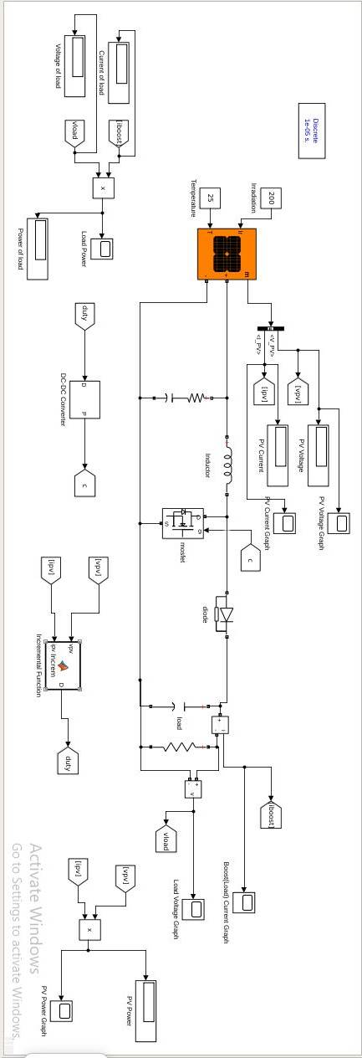

Fig. 11: Detailed model diagram

**PROJECT DETAILS**

**Department of Electrical & Electronics Engineering**

|  |  |  |  |  |  |  |  |  |
| --- | --- | --- | --- | --- | --- | --- | --- | --- |
| **Details of Student 1** | | | | | | | | |
| Name | Sayantika Paul | | | | | | | |
| Reg. No. | 170906082 | | Section | C | | Roll No. | | 16 |
| Mail ID | sayantikapaul99@gmail.com | | | Mobile No | | 9833062182 | | |
| **Details of Student 2** | | | | | | | | |
| Name | Suyash Bhatt | | | | | | | |
| Reg. No. | 170906140 | | Section | A | | Roll No. | | 18 |
| Mail ID | suyashbhatt09@gmail.com | | | Mobile No  N | | 7905029112 | | |
| **Project Details** | | | | | | | | |
| Project Title | Comparison and Implementation of MPPT Controllers | | | | | | | |
| Date of Reporting | 11/01/21 | Project Duration | | | | 4 months | | |
| **Guide details** | | | | | | | | |
| Name of Internal Guide | Dr. R. Shivarudraswamy | | | | | | | |
| Designation, Department & Organization | Associate Professor, Electrical and Electronics,  Manipal Institute of Technology, Manipal | | | | | | | |
| Mail ID | shivarudraswamy.r@manipal.edu | | | | Mobile | | 9448824360 | |